2018

Valga/Valka Tourist Information System
initial development task

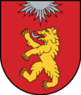

Sisukord
1. Description and purpose 2
2. Functional description 3
2.1 General description 3
2.2. Fillable forms 3
2.3 Administration area 4
2.3.1 General description 4
2.3.2 WYSIWYG editor 4
2.4 Social media integration 5
2.4.1 Sharing site content to social media 5
2.4.2 From social media to site 5
2.5 Interactive map 5
2.5.1 Automatic content on the map 5
2.5.2 Manual content on the map 6
2.6 Events and news export to other websites 6
2.7 Visitestonia.com / puhkaeestis.ee integration 6
2.8. Other functions 6
3. Public display screens 7
3.1. Displaying the info on the screens 7
3.2 Screen locations and sizes 7
3.3 Screen contents and categories 7
3.4 Wireframe of display screen contents 8
3.5 Technical description of screens 8
3.6 Screens setup process 8
4. Design & contents 8
4.2 Search engine optimization 9
4.3 Initial contents entry 9
5. Languages 9
6. Technical requirements 10
6.1 Web hosting 10
6.2 Domain name 10
6.3 Coding languages 10
6.4 Security and law compliance 10
7. Media 10
7.1 Photo and video 10
7.2 Logo 10
7.3 Visual identity 10
8. Use cases and workflows 11
8.1 New event 11
9. Data 0
9.1 Event 0
9.2 A public screen 0
10. Support 1
10.1 Training & instructables 1
10.2 Guarantee period 1

1. Description and purpose
Twin Town Valga–Valka is located at the southern border of Estonia and the northern border of Latvia. The moto of Valga–Valka is „One city, two states”.
With the support of the Interreg Estonia-Latvia program new Twin Town Centre will be developed in cooperation of Valga Municipality and Valka Municipality. The general aim of the project is to develop the Central Area and the Pedestrian Street in the border of Valga-Valka which is going to be an attractive and a unique heart of the town for both citizens and guests.
To support cross border activity and create a new common urban space that is re-connecting both parts of the town the project aims to improve public knowledge of Valga-Valka as cultural, historical and commerce area. To promote Valga-Valka as the joint town not only for the inhabitants but also for visitors, tourists and investors new multilingual tourism website is needed to put on public display information about tourism destinations, public events, leisure activities in Valga/Valka area and to advertise the municipalities as a desired tourism destination area.
The main goal of the solution is to provide an easy to find, detailed, thorough and precise tourism information to visitors and citizens to encourage tourists to visit Valga Municipality and more widely, Estonia, and Valka region and more widely Latvia as a tourism destination and make the Valga/Valka twin town more widely known in general.
Additionally a URL based solution to display events related and other selected information on public screens on various locations will be included.
To achieve this a visually attractive, easy to use web/mobile solution is to be developed that follows modern design standards and that is kept up-do-date and managed centrally by administrators at Valga Visitor’s Centre and Valka Tourism Information Bureau.
To bring the solution to life a visual identity is ordered separatedly and a web-based solution is developed as described in this development task, that takes in account the visual identity.

2. Functional description

2.1 General description
The system’s main function is to provide a unified platform for collecting and distributing events and tourism destinations related data in Valga/Valka region.
It will be an administered online system that provides a website view, views for public display screens and has fillable forms to collect and administer data about events and businesses in Valga/Valka region.
The solution must enable the owner to further develop the system in case of need. To achieve this, the database used in the solution will be selected or modeled in such a way that in the future in case of need it can be extended. An open source code solution is preferably used.
To model the database and discover all necessary data entities, interviews with the client will have to take place and the solution concept may change or improve as a result.
The solution must:
- support and look the same on all major browsers on their newest versions (Google Chrome v70, Mozilla Firefox v63, Safari v 11.1, Opera v55, Microsoft Edge v17).
- Internet Explorer support is not required. If IE is not supported by the solution and Internet Explorer usage is detected, site is not served and the user is asked to use a modern browser.
- Use MySQL as the database management system.
- comply with WCAG 2.0 AA standard for accessibility and pass the test at https://achecker.ca/checker/index.php
- validate in Facebook debugger tests for Open Graph metadata and other components (including https) https://developers.facebook.com/tools/debug/og/object/
- validate in Google PageSpeed tests for page speed and resource usage https://developers.google.com/speed/pagespeed/insights/
- be based on an open source solution. If a non open source solution or component is needed, its necessity is described in detail.
- built using best practices.
- Validate in W3C standards for HTML 5 and CSS 3 https://validator.w3.org/
- be built, written and documented so that a third party developer is able to understand its logic and continue its development if needed.
- support adding third party widgets via HTML iframes in web content and module locations.

2.2. Fillable forms
The solution incorporates fillable forms on the publicly accessible web in each language of the site.
- For local companies to send their updated business data
- For event organisers to send their events related data
The forms will have protection to prevent any spam being sent through them. If necessary to achieve this, an authentication mechanism will be added to enable only permitted users to send data.
The data uploaded through the forms has to be reviewed and edited / corrected by the administering staff in the backend of the system. This means the forms data is saved to the database. The process to approve/reject uploaded data must be convenient and user friendly.

2.3 Administration area

2.3.1 General description
All website contents and elements are editable by the administrator – the website, user rights, contents, modules and widgets are fully administered through the backend.
No content is hard coded or non-editable by administrators.
Administration area is available in the following languages: English, Latvian, Estonian.
The administrator area includes, but not limited to:
- Administration of static content and creation of pages and categories with a WYSIWYG editor, including Open Graph related information for social sharing (at minimum: title, description and share media (image, video)).
- news content and their categories; creation of news pages with a WYSIWYG editor
- events and categories
- modules (galleries, menus, sidebars, header/footer)
- frontpage content blocks management (news, events, slideshows, custom blocks)
- translations for each piece of content (page, event, module)
- users and their permissions. Permission levels similar to those in WordPress
- public screens: adding/removing screens and categories; management of information (events data, urgent messages, custom content) displayed on each public screen views (per screen and per category); setting priority of events and logic for displaying high priority events more frequently;
- event organizers’ submitted events
- business owners submitted business data

2.3.2 WYSIWYG editor
- Files, documents and images can be uploaded via the WYSIWYG editor
- The editor will have at least the functions that are available in TinyMCE Advanced for WordPress. This will include but not limited to: formatting text, adding and editing tables, lists, changing fonts, font sizes and color, adding images and setting its text related position, adding videos, creating links, altering the source code (HTML) of the content.

2.4 Social media integration

2.4.1 Sharing site content to social media
Pages administration – a page (including events pages) that is separately accessible by the URL and thus shareable must have an option to set from administration:
- social media share image (Open Graph image)
- share video (Open Graph video if applicable)
- social media description (Open Graph description)
Pages display – pages will have a social share bar available, location to be set during the design process
Image gallery – images displayed in image gallery will have a social media share bar available on the image when hovered by the mouse in desktop view or tapped and held on in the mobile view.

2.4.2 From social media to site
A module is to be included in solution to display a feed of public images from selected accounts and selected hashtags from Instagram, Twitter and Facebook.
Administrators will have the option to define hashtags like #valga, #valka etc to define which public images will be displayed in the module. Additionally administrators must have the option to decline these kind of photos and videos from being displayed on the website one by one, if their contents are inappropriate for the tourism website.

2.5 Interactive map
A screen wide map is on the frontpage with layers. The free version of Google Maps API is preferred.
The initial layers in public view will be:
- tourism destinations (sights, antiquities, historical places/objects)
- food & drink
- accommodation
- events (with date range picker)
- base layer of map
The map will get new layers if new layer categories are created in the administration area.

2.5.1 Automatic content on the map
The map gets its contents data from various sources:
- tourism destinations – map XY pointer data as tourism destinations’ data fields
- food & drink - map XY pointer data as places data fields
- accommodation - map XY pointer data as places data fields
- events - map XY pointer data is an event’s additional info field; date data as event’s data field.

2.5.2 Manual content on the map
The map will have an option to set interest points (map markers) on layer and describe their data manually. The data will be displayed to the user when the marker is clicked.
The map points are displayed for administration and administered in administration area.

2.6 Events and news export to other websites
The solution will include an RSS feed with all site data available to publish information on other websites and RSS feed-based readers. This will enable but not only other website owners to publish news, events etc related information as widgets on their websites.

2.7 Visitestonia.com / puhkaeestis.ee integration
The solution will if possible, use as data source for Estonian (Valga vald) side the visitestonia.com / puhkaeestis.ee database to minimize double management of data.
Latvia site has already http://visit.valka.lv/ - which can be the importable data source of destinations in Valka area.

2.8. Other functions
- search – a search module is available and enables users to perform a keyword search on the site
- administering pages and subpages is easy – they can be added and removed easily and tied with menu items easily
- all pages are easily search engine optimizable on the admin side
- The website will have a map of contents
- There will be 2 types of content pages – static content pages and news pages.
- News pages will have news date and category available and displayed
- Content pages will maintain a version history with a possibility to restore an older version
- Content pages will have an autosave feature to prevent data loss when creating content
- Activities and content edits on the website administration area are logged to enable investigation of unauthorized changes to the site content
- Menus administration enables to add unlimited number of menu items to the menu and create an unlimited amount of menus to menu locations
- Menu items display text and link to content can be altered
- Website usage can be monitored with Google Analytics

3. Public display screens
The solution is planned and modeled so, that it can and will incorporate a web browser based information display system meant to distribute events related information over public display screens at various locations of Valga/Valka region (but not limited to).
There are already a number of screens of various sizes, fixed to place in various locations, but additional are to come. The solution must have a screens administration option included.
There are 2 main types info to be displayed on the screens:
- events (and related info) that will rotate on screens, as set
- custom messages, that will display as overlays on the top and bottom (see 3.3 and 3.4)
To achieve this, each screen is an entity that can belong to a group and has group options and specific to that screen options.

3.1. Displaying the info on the screens
The physical screens will be computers or TV-s, that are connected to the internet and display the specific URL webpage in full screen mode. Thus the solution needs to output these screen specific URL-s that the client’s IT personnel can set up on each screen.
The solution will let adminstrators administer contents per each screen (or screen category) and submit existing and new screens to categories, as needed.

3.2 Screen locations and sizes
Currently there are 5 screens with Full HD 1920x1080 resolution in landscape position in Valga, 5 more are predicted and on Valka side 5 screens are predicted. For Valga and Valka together - the number will be around 15 screens.

3.3 Screen contents and categories
Administering screens - each screen will have an option to be assigned to a category to adapt information set to display on that category. AND individual assignment options allow to display additional events per selected screen.
Each category will have options to set per that category which of the following information is displayed:
- events related info - event poster (A4 portrait or A3 landscape) + event description + video
- municipality news ticker (at the bottom as overlay, configurable background color, fixed height 1/12 of screen height) – source RSS feed of municipality website, configurable by admin – must be available for each screen category so that Valga and Valka municipalities both have the option to set their own news tickers
- emergency messages (at the top as overlay, configurable background color, configurable height) – messages to be set/activated upon need by admin in admin area (if not activated, the emercency messages section is hidden)

3.4 Wireframe of display screen contents
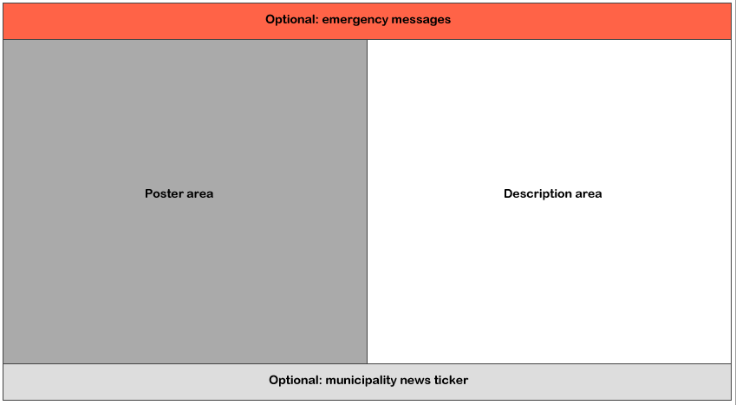

3.5 Technical description of screens
Screens are a monitor/TV+computer or information kiosk setups (screen with internal computer hardware) with an internet connection and remote administration set up, usually a Windows 10 environment.
The solution will provide a unique URL for each screen. Contents on that URL will be displayed on full screen mode with a common internet browser (i.e. Google Chrome) on each screen.

3.6 Screens setup process
The developer provides only the URLs for each screen and the option to add more screens per necessity.
Setting up screens to display the contents is the responsibility of the client.

4. Design & contents
The website has to be built using current web design, UI and UX standards and best practices.
The publicly accessible web is Mobile First Design, is responsive - adapts to screen sizes of viewing device (desktop, tablet, mobile).
The administration area is to be optimized for Desktop use.
The look and feel of the website are to be created using the design and visual identity materials given by the Client.

Design uses best practices to minimize page load time to validate in PageSpeed tests as per point 2.1 of this task description.
The website must, but not limited to:
- have the interactive map on the frontpage (see 2.5 for interactive map)
- have a fixed navigation menu at the top of the page and on the left side area where needed
- is responsive and adapts for comfortable use on desktop, tablet and mobile devices
- has a banners section on the frontpage and content pages that has a possibility to easily administer banners
- has a links section on the frontpage and or the content pages that has a possibility to easily administer the links
- has a language switching option at the front page
- news section on the front page (each news post has an option to be set or not set on the frontpage)
- events section on the front page (each event has an option to be set or not set on the frontpage)
- have the possibility to change the number of posts and events displayed on the frontpage

4.2 Search engine optimization
The design is created using SEO best practices in mind for search engine indexability (both contents and images).

4.3 Initial contents entry
The task includes initial contents insertion to system but not copywriting.
The customer prepares and forwards texts and images in separate files.
The tourism objects data on Estonian side is to be imported from Visitestonia.com / puhkaeestis.ee database.

5. Languages
The website public contents will be made available (and thus the translations easily manageable for the administrators). Initially the contents will be published and available are the following languages:
- Estonian
- Latvian
- English
- Russian
The website solution will include the possibility to add more languages via administration in case of need (e.g. Finnish, German) and translate contents to those languages similarily to the initial languages.
A language switcher will be visible for the visitor in an easily spottable position on the website. Additionally the system tries to guess visitor’s preferred language by detecting their language preferences and/or location.
Administration area workspace will be available in English, Latvian and Estonian languages.

6. Technical requirements

6.1 Web hosting
- The website will be hosted on a shared hosting environment at a reliable hosting provider.
- The resource limits (bandwitdth, CPU, RAM) must have on-demand upgrade possibility by the provider if necessary due to high demand (ie seasonal or event related website visit peaks)

6.2 Domain name
- The solution will serve from it’s own top level domain name or a subdomain of current domains i.e. https://visitvalgavalka.com or https://visit.valga.ee for Estonian and https://visit.valka.lv for Latvian versions. The exact domain name is to be specified during the execution of this task by the Customer.

6.3 Coding languages
- PHP and MySQL are preferred languages for the solution.

6.4 Security and law compliance
- The whole solution and contents, including administration area, will be served and received over encrypted connection (https) at all times.
- The solution will include the EU Cookie consent option
- The solution will have GDPR compliance related functionality to ask permission from the visitors to gather and process their data and not process data before user grants specific permissions (this includes the use of cookies and IP for statistics and other purposes).
- The site must be protected against and tested for any known vulnerabilities, including:
Cross-site scripting;
Information leakage;
Content spoofing;
Predictable resource location;
SQL injection;
Insufficient authentication;
Insufficient authorization;
Abuse of functionality;
Other vulnerabilities defined by Customer

7. Media

7.1 Photo and video
All photographic contents and videos are to be created and provided separatedly by clients and are not part of this task. The client will be fully responsible for the origin and rightful use of media contents on the webpage.

7.2 Logo
Logo is to be given by the client separatedly as part of the design materials.

7.3 Visual identity
Visual identity materials are to be given by the client separatedly. Visual identity materials are to be used when creating the general look and feel of the website.

8. Use cases and workflows

8.1 New event
A non profit or other organization notifies municipality of an upcoming event with the purpose to distribute event information on the website and its desired region’s public screens.
Now the event data must be:
- published on the website
- published on the frontpage events map
- published on selected screens

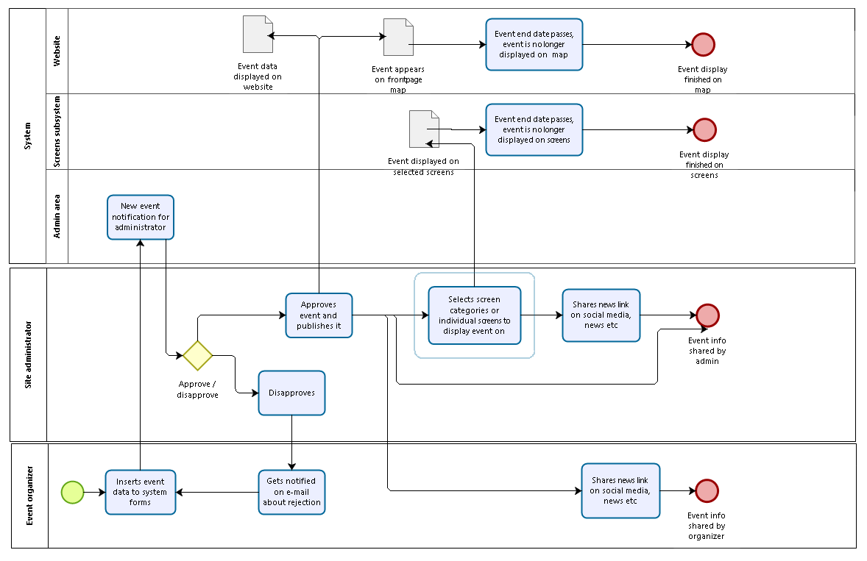
Figure 1: Event submission activity process

9. Data
To achieve the desired functionality these data entities must be present in the database (but not limited to). Additional entities to be agreed during database modeling and interviews.

9.1 Event
Name
Description
Category
OG description
Poster image URL
Video URL
OG image
OG video
location X
location Y
location country
location town
location address
date start
date end
time start
time end
language
ticket information
ticket URL
public display screen URL
public display screen category
public display screen by selection
is frontpage

9.2 A public screen
Name
Description
Category
Location X
Location Y
Location institution
Location address
Location country
Diagonal
Resolution
Model
public display screen category
current events
news ticker state
news ticker url
news ticker background color
extra message state
extra message background color
extra message contents

10. Support

10.1 Training & instructables
The tender must include:
- initial training of key personnel (administrators) to use the solution in its full functionality
- if necessary, training of the IT personnel
- instructions for use of the system by the key personnel (in Estonian and Latvian languages)
- additional support terms and cost

10.2 Guarantee period
The developer will eliminate all system imperfections and errors found by the client at no extra charge during one ( 1 ) year after the solution has been completed and handed over for use by the Customer.
The developer will guarantee paid support for the system for two ( 2 ) more consecutive years.
By presenting their offer the participant agrees to the tender and the these initial task description conditions.

